**Sample Output With ScreenShots:**

**1) List all users:**

Request: GET /api/users

Response:

200 OK

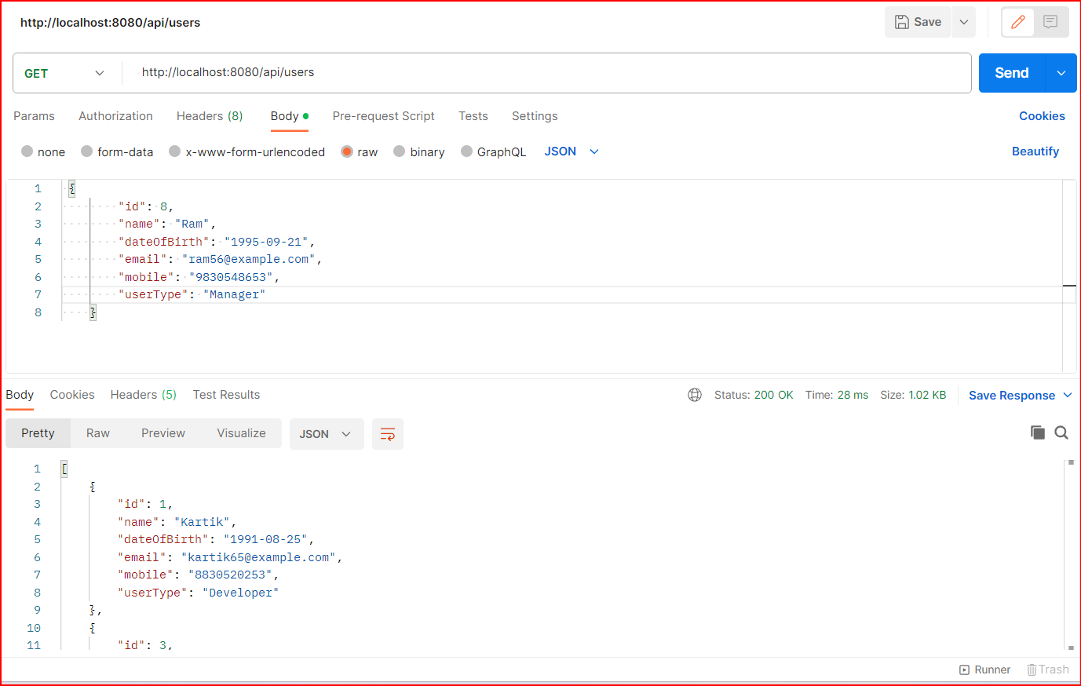

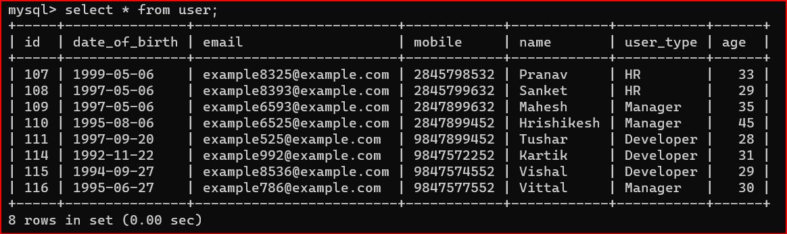

Body:

[

    {

        "id": 1,

        "name": "Kartik",

        "dateOfBirth": "1991-08-25",

        "email": "kartik65@example.com",

        "mobile": "8830520253",

        "userType": "Developer"

    },

    {

        "id": 3,

        "name": "Mahesh",

        "dateOfBirth": "1996-08-17",

        "email": "mahesh96@example.com",

        "mobile": "9145199845",

        "userType": "Developer"

    },

    {

        "id": 4,

        "name": "Pranav",

        "dateOfBirth": "1995-08-29",

        "email": "pranav99@example.com",

        "mobile": "8830865253",

        "userType": "Manager"

    },

    {

        "id": 5,

        "name": "Sanket",

        "dateOfBirth": "1989-02-29",

        "email": "sank869@example.com",

        "mobile": "8830535253",

        "userType": "HR"

    },

    {

        "id": 6,

        "name": "Tushar",

        "dateOfBirth": "1993-06-19",

        "email": "tushar5569@example.com",

        "mobile": "9830535253",

        "userType": "Manager"

    },

    {

        "id": 7,

        "name": "Hrishikesh",

        "dateOfBirth": "1993-06-19",

        "email": "hrishi576@example.com",

        "mobile": "9830537653",

        "userType": "Developer"

    },

    {

        "id": 8,

        "name": "Ram",

        "dateOfBirth": "1995-09-21",

        "email": "ram56@example.com",

        "mobile": "9830548653",

        "userType": "Manager"

    }

]

**2)**

**i) Filter by userType:**

Request: GET /api/users?userType=Developer

Response:

200 OK

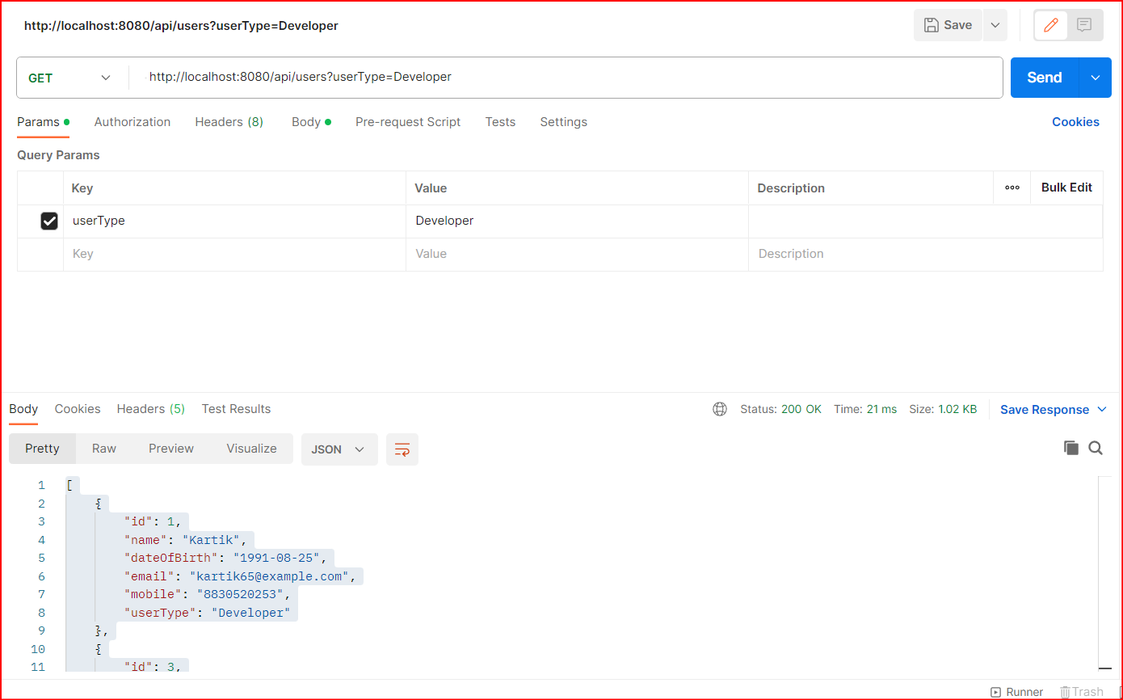

**ii) Filter by age group (age >= 30 and age <= 40):**

Request: GET /api/users?ageGreater=30&ageLesser=40

Response:

200 OK

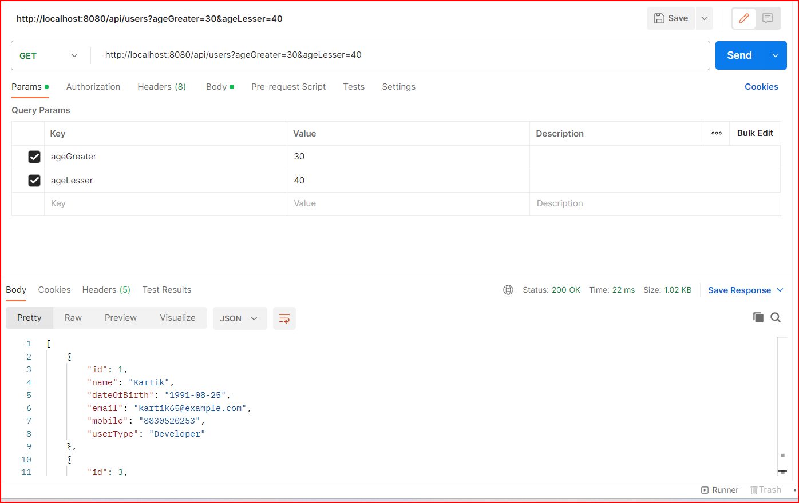

**iii) Filter by age (age >= 30):**

Request: GET /api/users?ageGreater=30

Response:

200 OK

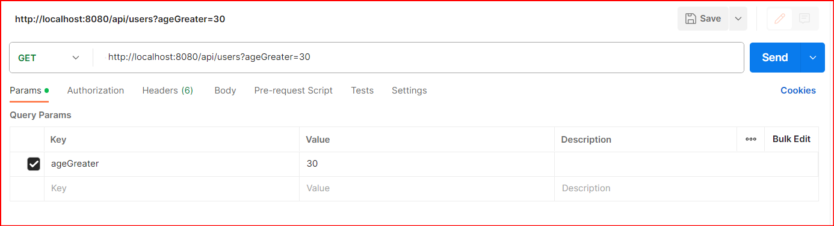

**iv) Filter by age (age <= 40):**

Request: GET /api/users?ageLesser=40

Response:

200 OK

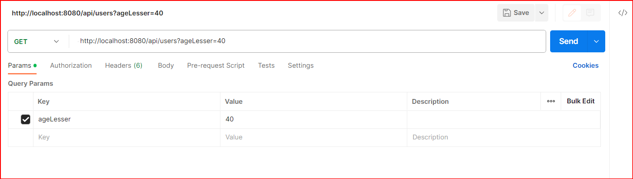

**iv) Filter by name, userType, and age group:**

Request: GET /api/users?nameFilter=Ma&userType=Developer&ageGreater=30&ageLesser=40

Response:

200 OK



